

***C# Basics***

**Lab Guides**

|  |  |
| --- | --- |
| Document Code | 25e-BM/HR/HDCV/FSOFT |
| Version | 1.1 |
| Effective Date | 20/11/2012 |

**Hanoi, 06/2019**

RECORD OF CHANGES

|  |  |  |  |  |  |
| --- | --- | --- | --- | --- | --- |
| No | Effective Date | Change Description | Reason | Reviewer | Approver |
|  | 01/Oct/2018 | Create new | Draft |  |  |
|  | 01/Jun/2019 | Update template | Fsoft template |  |  |
| 3 | 15/Apr/2019 | Review content | Review | TuTB |  |
|  |  |  |  |  |  |
|  |  |  |  |  |  |
|  |  |  |  |  |  |
|  |  |  |  |  |  |
|  |  |  |  |  |  |
|  |  |  |  |  |  |
|  |  |  |  |  |  |

Contents

Lab 12: Work With Try – Catch and Exception 4

Objectives: 4

Prerequisites: 4

Problem Description: 4

Guidelines: 4

Step 1: Create project named **ExceptionLab** in Visual Studio 4

Step 2: Add code to allow user enter file name, then read file content: 4

Step 3: Run the application and check result 6

Step 4: Add new class named MyException, inherit from Exception class 6

Step 5: Update Main method to use new custom exception 7

|  |  |
| --- | --- |
|  | **CODE: Net.S.L012**  **TYPE: SHORT**  **LOC: 100**  **DURATION: 30 MINUTES** |

# Lab 12: Work With Try – Catch and Exception

Objectives:

* Understand how to use try, catch and finally.
* Understand how to create new exception.

Prerequisites:

* Download and installs Visual Studio (included .net Framework)

Problem Description:

* Use try-catch-finally to hand exception when user enter age
* Create new exception

Guidelines:

### Step 1: Create project named **ExceptionLab** in Visual Studio

### Step 2: Add code to allow user enter file name, then read file content:

static void Main(string[] args)

{

Console.Write("Input your file name: ");

//// Read the file name with location

var filePath = Console.ReadLine();

StreamReader streamReader = null;

try

{

//// Try to open file as StreamReader

streamReader = new StreamReader(filePath);

var line = string.Empty;

//// Read line by line then print to console window

while ((line = streamReader.ReadLine()) != null)

{

Console.WriteLine(line);

}

}

catch (ArgumentException argumentException)

{

//// Hand exception when file name is empty

Console.WriteLine("File name is empty.");

}

catch (FileNotFoundException fileNotFound)

{

//// Hand exception when file not found.

//// May user is wrong location or spelling

Console.WriteLine("File not found. Please check you location or spelling.");

}

catch (IOException ioException)

{

//// Hand exception when could not open the file.

Console.WriteLine("Could not open the file. Please check permision on your file.");

}

catch (Exception exception)

{

//// Hand general exception.

//// Put it at the bottom of all

Console.WriteLine(exception.Message);

}

finally

{

//// Should be close stream all ways

if (streamReader != null)

{

streamReader.Close();

}

}

Console.ReadKey();

}

### Step 3: Run the application and check result

Outputs

**Input 1:** do not enter any text, press Enter

**Output 1:**

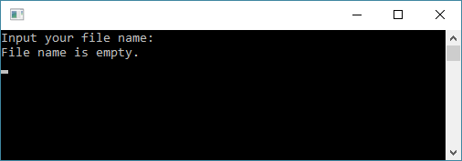

**Input 2:** enter wrong file name

**Output 2:**

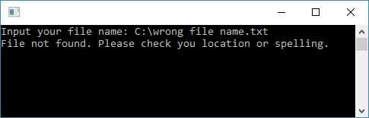

### Step 4: Add new class named MyException, inherit from Exception class

public class MyException : Exception

{

public MyException()

{

}

public MyException(string name)

: base(string.Format("The file {0} is not allow !!!", name))

{

this.HelpLink = "https://docs.microsoft.com/en-us/";

}

}

### Step 5: Update Main method to use new custom exception

…….

try

{

if (filePath.ToLower().EndsWith(".exe"))

{

throw new MyException(filePath);

}

//// Try to open file as StreamReader

……

}

…….

catch (MyException myException)

{

//// Hand exception when file is executor

Console.WriteLine(myException.Message);

}

catch (Exception exception)

{

//// Hand general exception.

//// Put it at the bottom of all

Console.WriteLine(exception.Message);

}

…..

Outputs

**Input 3:** enter the file name “hello.exe”

**Output 3:**

